Different Levels of Abstraction
Of Basic Gates
● Gate-Level (or) Structural modeling:
Verilog HDL supports built-in primitive gates modeling.
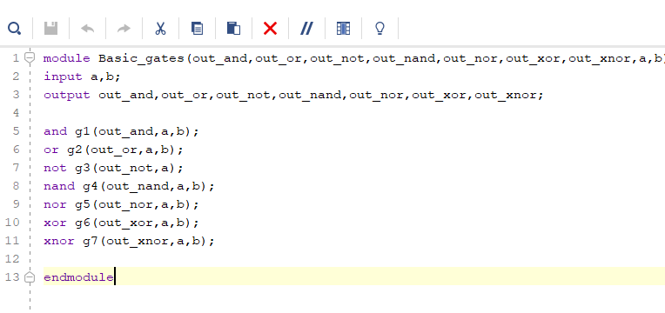
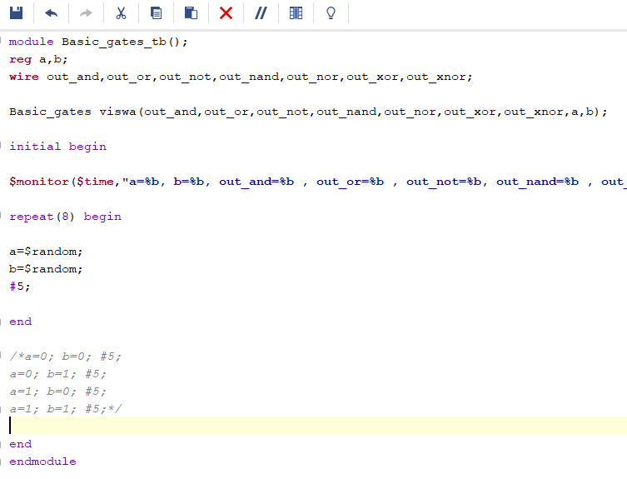
Dataflow modelling:
Mainly used to describe combinational circuits. The basic mechanism used is the continuous assignment

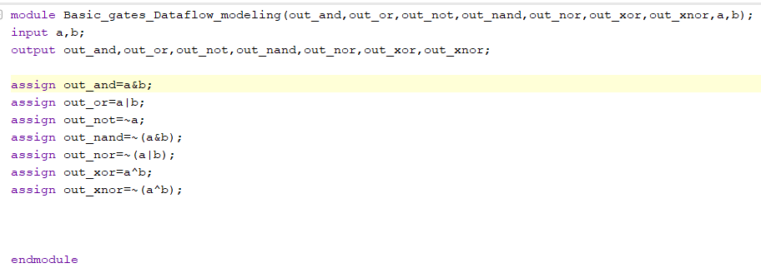

Behavioral modeling:
Used to describe complex circuits (primarily sequential). Mechanisms: initial and always statements.
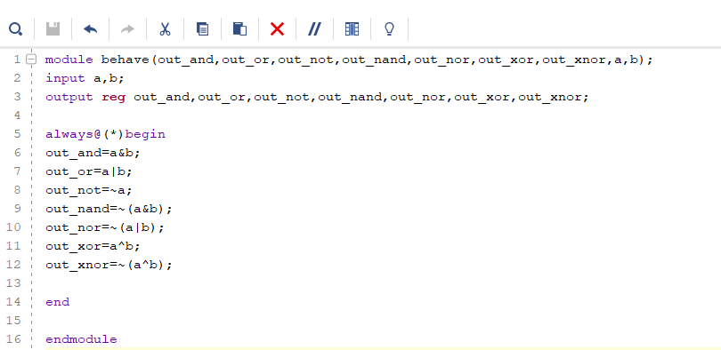

wave
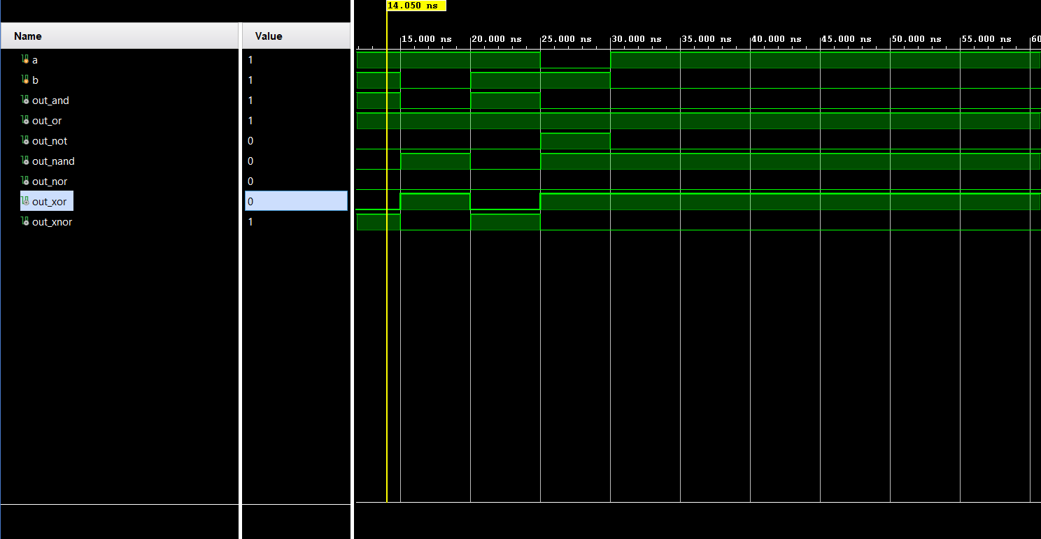

output
